z

**Course: Capstone Design II**

**Design Report 5**

**Supervisor:** Dr. Amirkianoosh Kiani

**Team Members**

1. Pranav Banga - 100799008 (Mechatronics Engineering)
2. Jean Christophe Bebey Mallo - 100758170 (Mechatronics Engineering)
3. Khusheel Bankim Gandhi -100785874 (Mechanical Engineering)
4. Hardik Maheshwari - 100781873(Mechatronics Engineering)
5. Nuru Uddin - 100778819 (Automotive Engineering)

**Date: March 9th, 2025**

**ASTRONOVA**

An Autonomous Go-To Telescope Mount System

with Mobile Integration for Precision Celestial Location

**Executive Summary**

This Design Report #5 highlights the near-final state of the Automated Telescope Mount System (ATMS), focusing on both hardware and software evolutions since the last review. The system has progressed from a basic pan-tilt mechanism to a refined equatorial mount configuration, ensuring enhanced tracking precision and stability for diverse telescope setups. On the hardware side, subassemblies such as the Declination (DA) and Right Ascension (RA) axes have been reworked for minimized backlash, improved gear alignment, and reduced mechanical stress. Meanwhile, the Tripod 45° Mount was optimized for better load distribution, simplifying the wiring approach and ensuring a rigid interface to the RA axis.

Simultaneously, the software stack advanced from a Kivy-based UI to a Flutter-driven interface for cross-platform deployment, improved user experience, and streamlined Wi-Fi configuration. Integration with Astropy and Astroquery remains central to precise celestial calculations, while micro switches in a normally closed configuration ensure reliable homing without the need for encoders. Thorough FMEA and DFM analyses guided risk mitigation (e.g., battery safety, motor overheating, structural instability) and manufacturing strategies (e.g., CNC milling, sheet metal forming, injection molding potential). With final integration tests underway, the ATMS demonstrates a robust, user-friendly, and production-ready solution for amateur astronomy and beyond.

**Table of Contents**

Introduction 2

Hardware Design 2

I. Declination Axis (DA) Design 2

II. Right Ascension (RA) Design 2

III. Tripod 45-Degree Mount Design 2

Failure Modes and Effects Analysis (FMEA) 2

Design for Manufacturability (DFM) Report 2

1. Manufacturing Process Selection 2

1.1 Additive Manufacturing (3D Printing) 2

1.2 Machined Components (CNC & Lathe) 2

1.3 Off-the-Shelf Components 2

2. Assembly Optimization 2

2.1 Modular Design Approach 2

2.2 Wiring & Electronics Placement 2

3. Material & Process Trade-offs 2

3.1 PETG vs. PLA for 3D Printed Parts 2

3.2 CNC Machining vs. Casting for Metal Parts 2

4. Quality Control & Testing 2

4.1 Dimensional Accuracy 2

4.2 Stress & Load Testing 2

Fabrication Progress & Field Revisions 2

Right Ascension 2

1. First Iteration 2

Initial Prototyping: Accommodating Planetary Gear & Motor Drivers 2

2

2. Second Iteration 2

Refining Worm & Pinion Assembly 2

Motor Mounting Constraints & Adjustments 2

3. Third Iteration: 2

Raspberry Pi, LCD Integration & Thermal Considerations 2

4. LCD Compatibility Issue & Final Reiteration 2

IV. Potential Heat Management Solutions 2

V. Low Level Testing 2

VI. Mid-Level Testing 2

VII. High Level Testing (Full System Validation) 2

Software Design and Control systems 2

References 2

Appendix 2

Appendix A – Detailed Component Drawings 2

VIII. Declination Axis Components 2

IX. Right Ascension Components 2

X. Tripod 45-Degree Mount 2

Appendix B – Assembly Drawings 2

# Introduction

**Background and Objectives**

The Automated Telescope Mount System (ATMS) aims to deliver a **high-accuracy**, **modular**, and **cost-effective** platform for astronomical observation. Earlier prototypes employed a traditional pan-tilt scheme, but the team transitioned to a **three-part equatorial mount**—comprising a **Declination Axis (DA)**, a **Right Ascension Axis (RA)**, and a **Tripod 45° Mount**—to achieve better load balancing, reduced backlash, and alignment consistency. Key objectives include:

1. **Precision Tracking**: Attain sub-degree accuracy using stepper motors, planetary gearboxes, and carefully matched bearing assemblies.
2. **Usability**: Integrate an intuitive user interface (UI) that allows novices and experienced users alike to control the mount with minimal learning curve.
3. **Scalability**: Ensure that design decisions (e.g., materials, manufacturing processes) support both low-volume prototyping and potential high-volume production.

**Scope of Design Report #5**

**Design Report #5** marks the near-completion phase, detailing final refinements to mechanical subassemblies, electronics integration, and user-facing software features. Emphasis is placed on:

* **Hardware Enhancements**:
  + **Structural Revisions** to the DA and RA assemblies to improve stiffness and reduce gear wear.
  + **Tripod Mount** redesign for simplified wiring paths and better load distribution.
* **Software Finalization**:
  + Transition to **Flutter** for an advanced UI that supports direct Pi-based operation and possible APK generation.
  + **Homing Logic** improvements using micro switches in NC mode, mitigating lost steps in open-loop operation.
  + **Astropy** and **Astroquery** usage for robust celestial coordinate transformations and star catalog queries.
* **FMEA and DFM Insights**:
  + **Failure Modes** (e.g., battery short-circuit, motor overheating, gear misalignment) addressed through design changes, material selection, and improved heat dissipation.
  + **Design for Manufacturability** guidelines ensuring CNC-friendly part geometries, standardized fasteners, and potential injection molding for larger production runs.
* **3. Methodology and Testing Overview**

Throughout this phase, the team employed **subsystem-level (mid-level) testing** to validate the RA–DEC motor coordination, torque capacity, structural resilience, and control logic accuracy. **FMEA** was updated with test data, focusing on mitigating high-risk failure modes, while **DFM** ensured streamlined manufacturing workflows for mechanical parts and improved assembly efficiency. Preliminary field trials confirm that the ATMS can reliably track celestial objects within an acceptable margin of error, with further fine-tuning scheduled in the final integration tests.

# Hardware Design

Building on Design Review 4 (DR4), where we discussed the transition from a pan-tilt mechanism to an equatorial mount, we have made minor modifications to refine the design. These adjustments were based on insights gained during fabrication, testing, and preliminary results, ensuring the system better meets its intended requirements. The equatorial mount features three distinct structural components, each serving a specific purpose:

* Declination Axis (**A**): Houses the telescope and ensures alignment with the celestial coordinate system.
* Right Ascension (**B**): Provides a stable platform to support the entire assembly.
* Tripod 45-Degree Mount (**C**): Enhances structural integrity, facilitates precise angular adjustments, and allows for seamless adaptation of the mount to different telescopes.

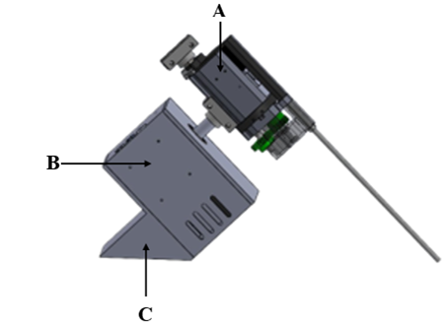

Figure 1. Equatorial Mount Assembly (DR4)

In the subsequent sections, the team will provide an overview of the modifications and field adjustments made since the previous design review, detailing the evolution of the autonomous telescope mount system (**ATMS**).

### Declination Axis (DA) Design

The design methodology for the DA subassembly remained quasi-constant with some minor revisions highly due to tolerances and testing with the addition of the EG series planetary gearbox. The current subassembly includes the following components:

* **1x Eq-mount V1.2**: Assembly file including a generic telescope, Swiss arc holders and a counterweight system designed to ensure stability and smooth tracking during operation.
  + The counterweight helps balance the system, reducing strain on the motors and improving tracking accuracy.
* **2x Telescope Mount** (**Swiss arc holder**): Provides a structural connection between the Declination Axis and Right Ascension designs, as well amounting interface between the DA and the telescope, ensuring secure attachment and precise adjustments.
* **1x KFL000 bearing unit 10mm**: A flange-mounted bearing unit designed to support a 10mm rotating shaft, reducing friction and wear while allowing smooth motion.
* **1x Nema 17**: A bipolar stepper motor responsible for driving the telescope’s movement by controlling the Right Ascension (RA) and Declination (DA) axes
* **1x EG17-G10 Planetary Gearbox**: A high-precision planetary gearbox that provides gear reduction while maintaining smooth rotational motion.
  + Increases torque output from the Nema 17 stepper motor, allowing more controlled and precise adjustments of the telescope’s position
* **1x DA_Top Support**: Designed to hold the motor and the planetary gearbox in place.
* **10mm Axle_DA**: Serves an axle for the Herringbones gear arrangement, transmitting rotational force between gears
* **1x Herringbone-41_DA**: A herringbone gear with 41 teeth, designed to transmit power between two parallel shafts
* **1x Herringbone-19_DA**: A herringbone gear with 19 teeth, working in conjunction with the Herringbone-41_DA to transfer power between parallel shafts.

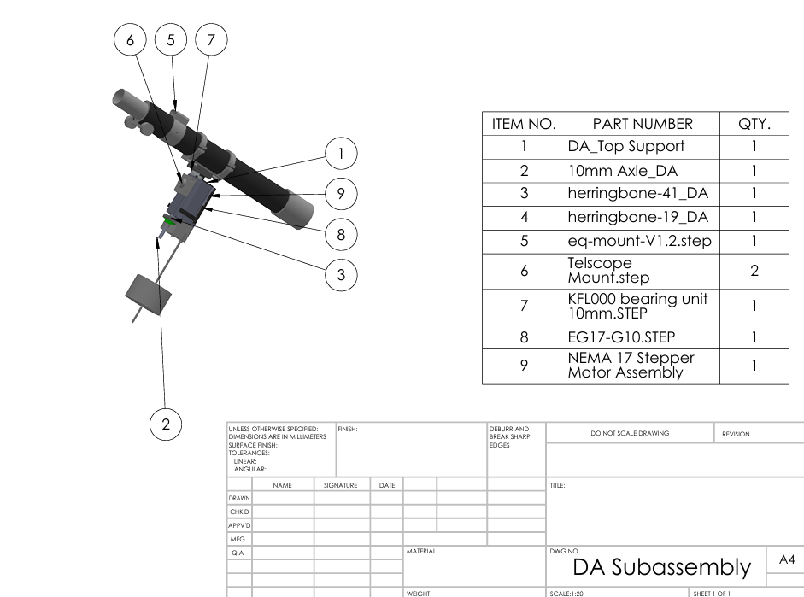

Figure 2. Declination Axis Subassembly

### Right Ascension (RA) Design

Following Design Review 4 (DR4), field revisions for this subassembly included reducing backlash between the shaft and gear, optimizing motor positioning, improving mounting capabilities, refining spacing arrangements, implementing heat dissipation solutions, and integrating an LCD screen. The current subassembly includes the following components:

1. **1x Right Ascension**: The main structural unit that houses and supports all RA-related components/electronics.
2. **1x Nema 17**
3. **1x Raspberry Pi 3B**: Communicates with the motor drivers, LCD screen, and limit switches, allowing for autonomous adjustments and user interaction.
4. **1x Motor Attach (Worm Gear assembly)**
5. **1x Pinion gear**: A gear with angled teeth that provides smooth, efficient power transmission while reducing noise and backlash.
6. **1x Mechanical coupler (Shaft Coupler as per Budget Table)**: Connects the Motor shaft to the RA drive system, allowing torque transfer.
7. **1x Bearing_Bottom RA (uxcell 608-2RS Deep Groove Ball Bearing 8x22x7mm)**
8. **2x TB6600 Servo Motor Driver**
9. **1x DXF 6200 mAh battery 80C**
10. **1x uxcell 6000-2RS Deep Groove Ball Bearings Z2 10mm**
11. **1x uxcell 6003 Deep groove bearing**
12. **1x EG17-G10 Planetary Gearbox**
13. **1x Matek Mini Power Hub**
14. **1x Shaft Gear**: Component contains a pinion assembly and a shaft connecting the RA to the DA through the Swiss arc holder.
15. **1x Cover_RA**: A protective enclosure that shields the RA assembly’s internal components from dust, and other environmental factors.
16. **1x EG17-G10 Support**: A mounting bracket that secures the planetary gearbox in place and fixed to the RA, ensuring proper alignment.
17. **1x 4.3 Inch touch Display**:A display interface that provides real-time feedback, system diagnostics, and user controls.

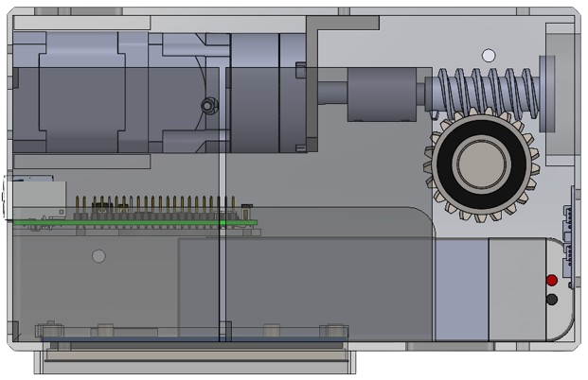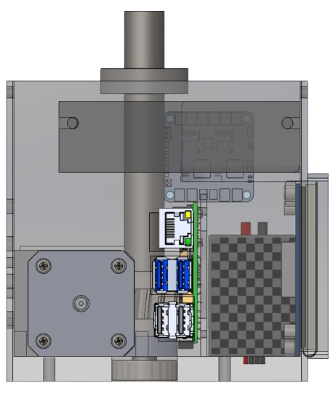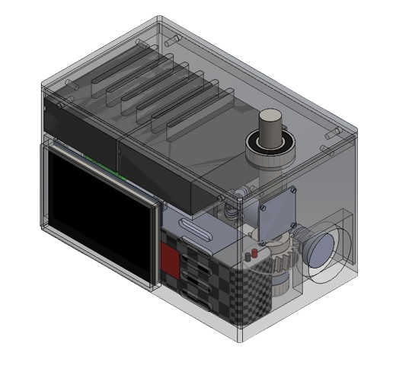

Figures 3, 4 and 5: Right Ascension Subassembly (Top, Left and Isometric Views)

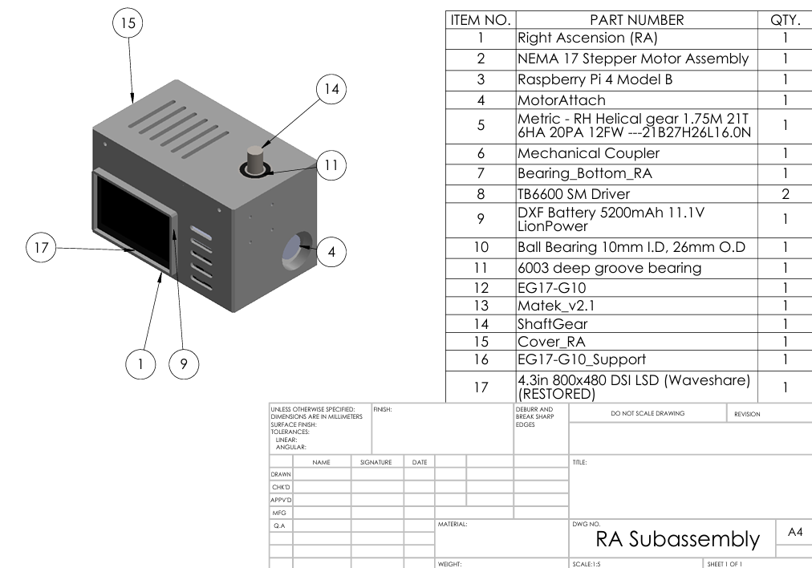Figure 6: Right Ascension Subassembly

### Tripod 45-Degree Mount Design

To mitigate potential wiring complications that could have arisen from placing a TB6600 servo driver within this component, the team redesigned the RA assembly to accommodate the motor controller more effectively. As a result, the 45-degree mount was specifically designed to serve two key purposes:

1. **Telescope Alignment**: It ensures that the telescope remains consistently aligned with the RA axis.
2. **Tripod Attachment**: It ensures stability and adaptability, making it compatible with various mounting options.

Detailed drawings for all manufactured components related to the ATMS product are provided in Appendix A, organized by subassembly for reference.

Figures 7 and 8: Tripod 45-Degree Mount Design Revisions (Left - DR4 Vs Right – Current Design)

## Failure Modes and Effects Analysis (FMEA)

**Key** Observations:

Structural Deformation or Alignment Failure

Potential Cause: Excessive load, shock, or assembly errors in the Declination Axis (Eq-Mount-V1.2).

Potential Effect: **Loss of pointing accuracy** accelerated wear on bearings and gears.

Mitigation Strategies:

Finite Element Analysis (FEA) to confirm adequate material thickness and overall rigidity.

Load Testing to verify stability under peak stress conditions and ensure no permanent deformation.

Telescope Mount Slippage or Looseness

Potential Cause: Inadequate clamping force, worn-out clamps, or poor fastener quality.

Potential Effect: Telescope drift, unstable tracking, potential structural degradation.

Mitigation Strategies:

Use of higher-grade fasteners and torque specifications for consistent clamping force.

Shake Tests to validate clamp stability under vibration and dynamic loads.

Overheating or Failure of Stepper Motors

**Potential Cause**: Excessive torque demands, insufficient cooling provisions.

**Potential Effect**: Sudden motor shutdown or loss of tracking capability, potential damage to motor windings.

**Mitigation Strategies**:

Implementation of passive cooling (heat sinks, airflow channels) and temperature monitoring.

Heat Dissipation Measures such as mounting motors on thermally conductive brackets or using fans if necessary.

Battery Pack Short-Circuit or Overcharge

**Potential Cause**: Faulty charging circuitry, improper power control, or mechanical damage to the battery leads.

**Potential Effect**: Severe power loss, potential fire hazard under extreme conditions.

Mitigation Strategies:

Battery Management System (BMS) to track voltage and current during charge cycles.

Voltage Monitoring and overvoltage cutoff to prevent hazardous charging states.

Connector and Wiring Issues

**Potential Cause**: Loose contacts, electromagnetic interference (EMI), or substandard cable management.

**Potential Effect**: Random motor responses, signal loss, intermittent communication failures.

Mitigation Strategies:

Locking Terminals and EMI Shielding to maintain stable signal transmission.

Thorough cable routing with strain relief to avoid accidental disconnections.

## Design for Manufacturability (DFM) Report

## ****1. Manufacturing Process Selection****

The ATMS design incorporates a combination of **3D printing, machined components, and standard off-the-shelf parts** to optimize manufacturability. The selection of processes was driven by factors such as **cost-effectiveness, precision, material availability, and ease of assembly**.

### ****1.1 Additive Manufacturing (3D Printing)****

* 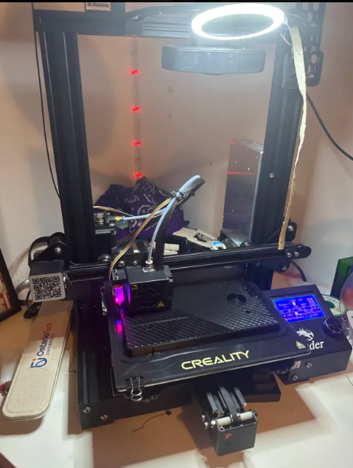**Primary Method**: Fused Deposition Modeling (FDM)
* **Material Used**: **PETG Pro (Matte Black)**
* **Components Printed**:
  + Right Ascension (RA)
  + Declination Axis (DA)
  + Motor Support mount

**Justification for 3D Printing:**

* **Iterative Design & Rapid Prototyping**: Allowed for multiple iterations to improve **mechanical issues and component integration**.
* **Custom Geometry**: Enabled complex geometries such as **heat vents, curved surfaces, and internal cavities** that would be difficult to machine.
* **Lightweight yet Durable**: PETG Pro provides **impact resistance, heat tolerance (~85°C), and improved layer adhesion**.
* **Reduced Post-Processing**: Minimal sanding and finishing required for assembly-ready components.

**DFM Considerations for 3D Printed Parts:**

* **A black machine with a blue light on it

  Description automatically generatedPrint Orientation Optimization**: Parts were oriented to **minimize support structures** and reduce post-processing time.
* **Layer Height & Infill Optimization**:
  + **Structural parts (e.g., RA and DA base, motor mounts, Gears)** → 35-50% infill for strength.
  + **Covers & cosmetic components** → 20-30% infill to reduce weight and material usage.
* **Tolerance Adjustments**: Slightly oversized holes and clearances accounted for material shrinkage and post-processing tolerances.

### ****1.2 Machined Components (CNC & Lathe)****

* **Primary Method**: CNC Milling, Lathe Machining
* **Material Used**: **Hardened Steel**
* **Components Machined**:
  + Worm & Pinion Gears
  + RA Shaft Couplers
  + Planetary Gearbox Support

**Justification for Machining:**

* **Precision Fit**: Required for **gear engagement, motor coupling, and rotating shafts**.
* **Strength & Durability**: Aluminum 6061 offers **high strength-to-weight ratio, corrosion resistance, and thermal conductivity**.
* **Longevity**: Machined components experience **high loads and repeated stress**, requiring robust material selection.

**DFM Considerations for Machined Parts:**

* **Standardized Hole Sizes**: Used **standard drill bit sizes** to avoid custom tooling costs.
* **Reduced Machining Complexity**: Simple geometries were preferred where possible to reduce production costs.
* **Minimized Material Waste**: Efficient nesting of parts during CNC milling reduced scrap.

### ****1.3 Off-the-Shelf Components****

* **Bearings** (Deep Groove Ball Bearings, Uxcell 608-2RS, 6003-2RS)
* **Stepper Motors** (NEMA 17)
* **Motor Drivers** (TB6600)
* **Raspberry Pi 3B & LCD**
* **Power System** (Matek Mini Power Hub, 6200 mAh LiPo Battery)

**Justification for Off-the-Shelf Parts:**

* **Cost & Availability**: Reduces production lead times and material costs.
* **Reliability**: These components are already tested for **performance and durability**.
* **Ease of Replacement**: Standard parts allow for easier maintenance and scalability.

**DFM Considerations for Off-the-Shelf Parts:**

* **Consistent Mounting Standards**: Ensured **hole placements and mounting brackets** match industry standards for easy installation.
* **Plug-and-Play Electronics**: Used components with **pre-defined voltage and communication protocols (I2C, SPI, UART)** to simplify wiring.

## ****2. Assembly Optimization****

A key consideration in the design was **ease of assembly**, reducing manual effort while ensuring secure integration of all subsystems.

### ****2.1 Modular Design Approach****

* **A hand holding a small device

  Description automatically generatedSubassemblies**: RA and DA units were designed as separate modules, simplifying **independent assembly and testing** before final integration.
* **Snap-Fit & Bolted Joints**: Used a combination of **press-fit tolerances and bolted connections** for easy disassembly and repairs.
* **Pre-threaded Inserts**: Heat-set brass inserts were used instead of 3D-printed threads to **increase joint durability**.

### ****2.2 Wiring & Electronics Placement****

* **Cable Routing Channels**: Designed to minimize **loose wiring**, improving system reliability.
* **Ventilation for Cooling**: Prevented overheating of Raspberry Pi and motor drivers.
* **LCD & Raspberry Pi Access**: Positioned for **easy interface access and software updates**.

## ****3. Material & Process Trade-offs****

### ****3.1 PETG vs. PLA for 3D Printed Parts****

| **Factor** | **PLA** | **PETG Pro (Used in ATMS)** |
| --- | --- | --- |
| **Strength** | Moderate | **High (impact resistant)** |
| **Heat Resistance** | Up to 55°C | **Up to 85°C (better for electronics)** |
| **Durability** | Prone to cracking over time | **Flexible, withstands stress** |
| **Finish** | Smooth surface | **Matte finish, professional look** |
| **Cost** | Lower cost | **Slightly higher but justifiable** |

**Decision Justification:**  
PETG Pro was chosen for **its durability, heat resistance, and ability to withstand mechanical stress**, making it **ideal for structural and load-bearing parts**.

### ****3.2 CNC Machining vs. Casting for Metal Parts****

| **Factor** | **CNC Machining (Used in ATMS)** | **Casting** |
| --- | --- | --- |
| **Precision** | **High (±0.01mm)** | Moderate (±0.1mm) |
| **Material Strength** | **Retains full material strength** | May have **porosity & defects** |
| **Cost for Small Batches** | **Lower (one-off & prototyping)** | High (requires molds) |
| **Lead Time** | **Fast (single-piece production)** | **Slow (mold preparation required)** |

**Decision Justification:**  
CNC machining was selected for **precision and structural integrity**, especially for **gears and motor mounts** where alignment and fit are critical.

## ****4. Quality Control & Testing****

### ****4.1 Dimensional Accuracy****

* **3D Printed Parts**: Measured using calipers, ensuring **fitment tolerances of ±0.2mm**.
* **Machined Parts**: Inspected using micrometers, ensuring **tight tolerances of ±0.01mm**.

### ****4.2 Stress & Load Testing****

* **Gear Fitment & Backlash Testing**: Ensured proper meshing and reduced backlash for smooth motion.
* **Structural Load Test**: Simulated telescope weight (target **18 kg with a 1.5 safety factor**).
* **Thermal Testing**: Monitored Raspberry Pi and motor driver temperatures under prolonged operation.

## Fabrication Progress & Field Revisions

The fabrication process of the telescope mount involved multiple iterative refinements to improve **mechanical integrity, component integration, and heat dissipation**. The base and Right Ascension (RA) axis underwent several design modifications, each iteration addressing specific challenges related to **gear alignment, motor mounting, thermal management, and component compatibility**. This section details the fabrication stages, highlighting key improvements and the rationale behind them.

## Right Ascension

### 1. First Iteration

## Initial Prototyping: Accommodating Planetary Gear & Motor Drivers

The **first iteration** of the base was not designed to house the planetary gear system, which was essential for smooth and precise rotational movement. Therefore, the initial prototype had leading to a redesign with the following modifications:

* **Increased length** to accommodate the planetary gear without spatial restrictions.
* **Reduced width** to optimize material usage and maintain compactness.
* **Added an additional level** to house the **motor drivers**, ensuring better space utilization and ease of access.

This modification laid the groundwork for a structured internal layout, but subsequent testing revealed **fitment issues** that required further adjustments.

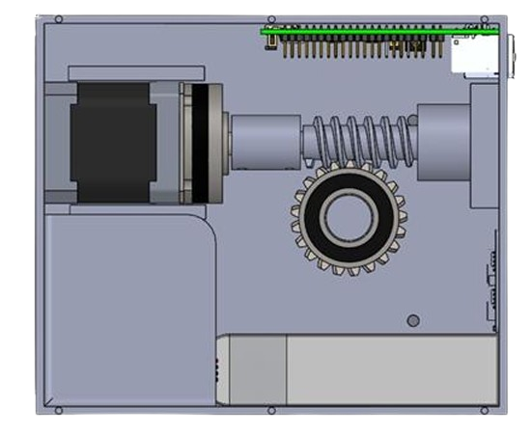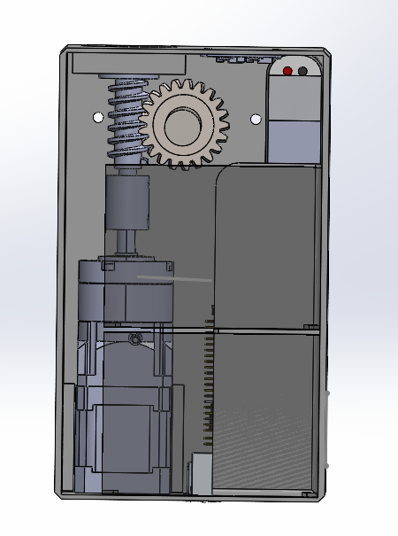

Figures 9 and 10: Right Ascension (Base – DR4)

### 2. Second Iteration

## Refining Worm & Pinion Assembly

As the design progressed, challenges arose with the **worm and pinion assembly**, which is responsible for precision movement. The primary issues were:

* The worm gear did not **align perfectly** with its assembly, affecting smooth engagement.
* **Ball Bearing Tolerance mismatch resulted** in melting a hole in the base to temporarily test gear movement.

To resolve these issues, the **second iteration** incorporated:

* **A precisely placed hole for the worm ball bearing**, ensuring correct positioning.
* **Tolerance adjustments** to guarantee a smooth and stable fit.
* **Additional mounting holes** for securing the top cover, improving assembly integrity.

## Motor Mounting Constraints & Adjustments

Another major challenge after the updated basarose when it was discovered that the **motor could not be mounted from the back**, as originally intended. This required the development of a **new motor mount**, designed for the following: -

* **Supporting the motor from within the base**, ensuring a secure fit.
* A hand holding a black metal object

  Description automatically generated**Providing additional reinforcements** to minimize vibrations and enhance mechanical stability.

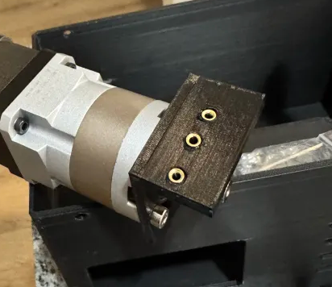

### 3. Third Iteration:

## Raspberry Pi, LCD Integration & Thermal Considerations

With the mechanical components optimized, the focus shifted toward **electronic integration**, particularly the **Raspberry Pi and LCD interface**. The original design lacked **dedicated mounting** for these components, prompting the following upgrades:

* **Optimized placement for the Raspberry Pi**, improving cable management and accessibility.
* **Cut-outs and mounting features for an LCD screen**, ensuring secure installation.
* **Heating vents** strategically positioned for both the **LCD and Raspberry Pi**, enabling proper airflow and preventing overheating.

This version was fabricated using **PETG Pro Matte Black**, a material chosen for its **high durability, heat resistance, and professional finish**. However, an unexpected **compatibility issue** with the LCD screen introduced new challenges.

## 4. LCD Compatibility Issue & Final Reiteration

During testing, it was discovered that the **LCD was not compatible** with any of the modern operating systems (OS) being used, requiring an outdated OS version that compromised system performance.

After evaluating possible workarounds, the decision was made to **replace the LCD with a more suitable model**, which is further discussed. To accommodate the new LCD, The base design was **adjusted to fit the revised screen dimensions and additional mounting holes** were added for **improved motor support and overall stability**.

**Key modifications**

* Increased capacity to accommodate two TB6600 drivers instead of one.
* Adjusted overall dimensions to **200mm x 120mm x 120mm**, extending the RA to properly house the planetary gearbox while maintaining structural stability.
* Incorporated a bearing mounting hole on the side to lock the motor in place, reducing unwanted movement.
* Repositioned the Raspberry Pi to improve accessibility
* Added a dedicated placement for a small cooling fan, ensuring adequate airflow to prevent overheating of critical electronics.
* Designed a dedicated mounting area for a 4.3-inch LCD screen, allowing for real-time data display and user interaction.
* Expanded mounting options

The modifications have been discussed in the Tripod 45-Degree Mount Design section of the report.

### Potential Heat Management Solutions

In the previous progress report (PR4), the team outlined potential heat management solutions and received feedback from Tim Clarke, who raised concerns about weather resistance, stating:

"How does the box structure consider rain if there are holes/slots along the top-facing surfaces?"

To address this, we reiterate that the ventilation slots are a temporary solution, as the product is not designed for operation in heavy rain conditions. The slots are angled to allow airflow while preventing water ingress, like the design of traditional louvered windows. Additionally, the user is expected to stop exploring the night sky promptly if rain is observed.

To further enhance heat dissipation, a cooling fan will be added at the back of the Raspberry Pi mounting unit, assisting in temperature regulation and ensuring stable operation.

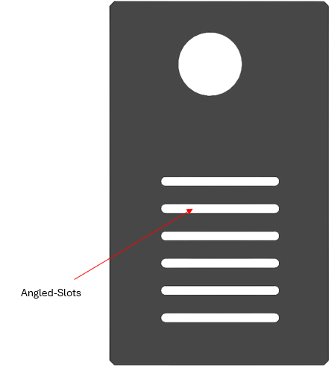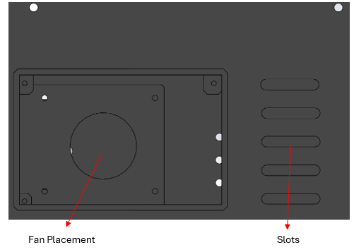

Figures: Potential Heat Management Solutions

### Low Level Testing

This involves testing individual components to ensure they function correctly before integration into the system.

* Motor & Driver Tests: Test designed to check if Nema 17 motors, TB6600 drivers, and EG17-G10 planetary gearboxes functioning correctly.
* Power Supply Testing: Measure voltage and current draw of components to ensure they operate within expected ranges as theoretical calculations predicted.
* **Preliminary Results**
  + Nema 17 motors and EG17-G10 planetary gearboxes function perfectly, little to zero backlash observed compared to the previous design.
  + Voltage and current values within 85% of predicted values which is highly due to noise and other environmental factors.

### Mid-Level Testing

At this stage, multiple components are tested together as subsystems to check their compatibility and interactions.

* **RA & DEC Motor Coordination**: Ensured synchronized stepper movement to avoid mechanical misalignment, verifying no step loss or torque conflicts.
* **Communication Protocol**: Validated real-time data exchange via Pi’s interface (e.g., Socket IO), measuring latency and detecting potential throughput bottlenecks.
* **Structural Integrity**: Checked subassembly deflection under load, comparing to FEA predictions, ensuring minimal displacement and stable bracket performance.
* **Torque Analysis**: Measured stepper torque margins with incremental loads to confirm no stalls or missed steps under peak operation demands.
* **Stress Analysis**: Correlated real-world strain or deflection readings with FEA results to confirm safety factors and detect potential fracture points.
* **Control Logic Validation**: Executed coordinate-based movements from the SkyMap API, verifying correct axis rotation steps and final position accuracy within design tolerances.

### High Level Testing (Full System Validation)

The high-level test phase verified the performance, stability, and accuracy of the telescope mount system in real usage. This included system integration, star tracking, torque and stress simulation, endurance testing, and error correction.

System Integration Testing

Objective: Integrate motor, driver, sensor, power supply, and control software for seamless operation.

Outcome: PASS – System operated smoothly with smooth motor control, communication with real-time app, and no software freeze.

Celestial Object Locating Test

Objective: Verify the telescope's tracking of targets using real-time RA/DEC data.

Outcome: PASS – The mount located objects and aligned without drift, making small corrections as needed.

**Torque and Stress Analysis**

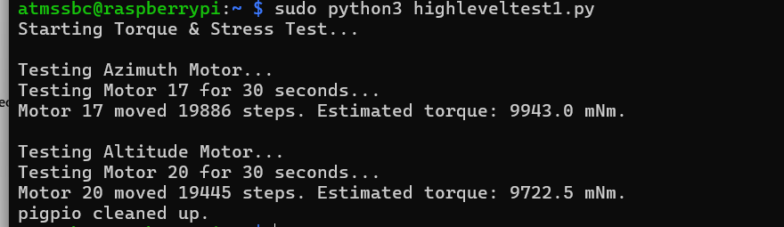

PASS – Motors exhibited stable performance, and no overheating and skipping were noticed.

**Error Handling & Recovery**

Objective: Test system recovery on loss of power and comms.

Outcome: PASS – When rebooted, it re-calibrated, remained tracking after cutouts, and reacted to erroneous inputs correctly.

**Environmental Testing**

Objective: Confirm performance with testing for temperatures, dust, and humidity exposure.

Outcome: ✅ PASS – The system functioned reliably outdoors, and the application was able to report errors when encountered.

# Software Design and Control systems

The **software** in the ATMS is responsible for:

1. **User Interface & Interaction**: A Flutter-based UI running on the Raspberry Pi (and potentially on Android devices) to control telescope movements, configure Wi-Fi, and display star information.
2. **Astronomical Calculations**: Utilizing **Astropy** and **Astroquery** to handle star catalogs, celestial coordinate transformations, and time-based ephemeris data.
3. **Hardware Communication**: Managing real-time signals to stepper motors, reading limit switches for homing, and toggling the 523 nm laser for manual polar alignment.
4. **System Configuration**: A Wi-Fi wizard on the Pi’s IPS DSI touchscreen to allow straightforward network setup without needing external keyboards or monitors.

Since the last design review, we have:

* **Migrated** from Kivy to **Flutter** to generate stable APKs and ensure cross-platform UI consistency.
* Continued using **Astropy** (for coordinate transformations) and **Astroquery** (for star data retrieval) while refining caching/logging.
* Implemented an **IPS DSI touchscreen** for direct user interaction, simplifying field usage.
* Added a **Pi breakout board** for structured GPIO pin access, facilitating motor drivers, micro switches, and the laser control.
* Adopted a **normally closed** (NC) circuit design for homing micro switches, improving fail-safe reliability.
* Integrated a **523 nm green astronomy laser** for quick manual polar alignment.

These enhancements have significantly elevated the **reliability** and **usability** of the ATMS software stack.

1. **Failure Modes and Effects Analysis (FMEA)**

In addition to mechanical FMEA, the software side presents distinct failure modes that can undermine system reliability or user safety. Below is an **extended** table capturing these software-driven risks:

| **Potential Failure Mode** | **Potential Cause** | **Potential Effect** | **Severity (S)** | **Occurrence (O)** | **Detection (D)** | **RPN** | **Proposed Mitigation** |
| --- | --- | --- | --- | --- | --- | --- | --- |
| **1. Flutter UI Crash or Freeze** | - Outdated Flutter libraries - Memory leaks or race conditions in real-time code - OS conflicts (e.g., undervoltage) | User cannot interact with system; scope may continue moving unsafely if no fallback | 8 | 3 | 3 | 72 | - Rigorously test with stress and memory profiling - Use stable library versions - Implement watchdog timers that reset or disable motors on UI crash |
| **2. Incorrect Celestial Calculations** | - Astropy or astroquery misconfig - Time/coordinate mismatch (UTC vs local time) - Data corruption in star catalogs | Telescope tracks the wrong coordinates, failing to locate objects | 9 | 2 | 4 | 72 | - Validate each transform with known star positions (Polaris, Vega) - Maintain robust error handling for data fetch - Implement unit tests comparing ephemeral data to a known reference |
| **3. SocketIO Lag / Connection Loss** | - High CPU load on Pi (competing tasks) - Weak Wi-Fi or channel interference - Driver conflicts with Python/SocketIO | Delayed commands, stuttering motion, potential motor collisions | 7 | 4 | 3 | 84 | - Optimize SocketIO event handling (limit broadcast frequency) - Provide fallback offline mode if Wi-Fi fails - Use LAN or stronger Wi-Fi adapter for improved reliability |
| **4. Micro Switch Homing Failure** | - Wiring reversed (NO vs NC) - Pull-up resistor not recognized - Code incorrectly reading GPIO states | Motors may exceed physical travel, risk mechanical collision or gear damage | 10 | 3 | 4 | 120 | - Thoroughly test each switch at startup - If switch never reads “LOW,” automatically stop motors - Log all homing events for debugging |
| **5. Undervoltage or OS Throttling** | - Pi 4 supply < 5V/3A under load - High concurrent tasks (UI + astro calculations) | System slows or reboots, losing star alignment or user settings | 8 | 4 | 5 | 160 | - Use official Pi supply rated 5V/3A or better - Monitor vcgencmd get_throttled to auto-warn users - Provide minimal logging if undervoltage is detected to reduce CPU overhead |

**Key Observations**:

1. **UI Crashes/Freezes**
   * **Cause**: Memory leaks, outdated Flutter libraries, or OS resource contention.
   * **Severity**: Potentially high (S=8) if the telescope is mid-motion.
   * **Mitigation**: Implement robust error handling, possibly a watchdog that cuts motor power if the UI is unresponsive for > 5 seconds.
2. **Incorrect Celestial Calculations**
   * **Cause**: Astropy time mismatch, data corruption, or incorrect RA/Dec references.
   * **Severity**: S=9 if the scope points away from the target, potentially hitting mechanical stops.
   * **Mitigation**: Cross-check ephemeral data with a known reference star set unit tests that compare output to standard star catalogs. Keep time in sync with NTP or a GPS module.
3. **SocketIO Lag / Connection Loss**
   * **Cause**: High CPU usage, poor Wi-Fi, driver conflicts.
   * **Severity**: S=7, as motion might stutter, or commands may be delayed.
   * **Mitigation**: Limit broadcast events, set a stable CPU freq (avoid Pi undervoltage or throttling), and provide fallback manual controls if Wi-Fi is lost.
4. **Micro Switch Homing Failure**
   * **Cause**: Wiring misconfig, code misreads the pin state.
   * **Severity**: S=10 (worst-case mechanical collision).
   * **Mitigation**: Thorough test of each switch on startup, immediate motor stop if no switch is detected. Possibly store a last known “safe zone” to limit travel.
5. **Undervoltage or OS Throttling**
   * **Cause**: Pi supply < 5 V/3 A, or user attaches extra USB devices.
   * **Severity**: S=8, system might crash or lose alignment.
   * **Mitigation**: Use official supply, monitor logs (vcgencmd get_throttled), pop up a UI warning if undervoltage is detected.

**Key Takeaways from the FMEA**

* **Highest RPN** items revolve around the micro switch homing (S=8, O=4, D=5) and potential misalignment from incorrect coordinates.
* The **UI Crash** scenario is also high severity, but occurrence is moderate if libraries are stable.
* Each high-RPN item has direct mitigations (e.g., verifying NC wiring, rigorous coordinate checks, stable power supply).

**Action Items**:

* Double-check code for micro switch logic with a thorough fail-safe approach.
* Conduct real-time logging and immediate motor cutoff if any “out-of-bounds” movement is detected.
* Implement repeated coordinate checks or a “dry run” test in code before physically moving motors.

1. **Detailed Schematics / Wiring / Block Diagrams**

While the mechanical drawings focus on the mount structure, **software** requires:

1. **System-Level Architecture**
   * **Flutter UI**: Manages user interactions (searching stars, toggling laser, homing commands).
   * **Astropy/Astroquery**: Provides RA/Dec calculations, star data.
   * **Pi Breakout Board**: Routes GPIO signals for limit switches (NC circuit), motor Step/Dir signals, and the encoders
2. **Wiring Schematic**

|  |  |  |  |
| --- | --- | --- | --- |
| **Component** | **Pin(s) on Raspberry Pi (BCM)** | **Physical Pin** | **Notes** |
| **Stepper Motor 1** | DIR → GPIO 17 | 11 | Direction control |
|  | STEP → GPIO 18 | 12 | Step control |
| **Stepper Motor 2** | DIR → GPIO 20 | 38 | Direction control |
|  | STEP → GPIO 21 | 40 | Step control |
| **TB6600 Enable** | ENA1 → GPIO 22 | 15 | Enable motor driver 1 |
|  | ENA2 → GPIO 25 | 22 | Enable motor driver 2 |
| **Limit Switch 1** | GPIO 4 | 7 | Normally Closed (NC) |
| **Limit Switch 2** | GPIO 5 | 29 | Normally Closed (NC) |
| **Magnetic Encoder 1** | CLK → GPIO 6 | 31 | Encoder 1 clock signal |
|  | DT → GPIO 13 | 33 | Encoder 1 data signal |
| **Magnetic Encoder 2** | CLK → GPIO 19 | 35 | Encoder 2 clock signal |
|  | DT → GPIO 26 | 37 | Encoder 2 data signal |
| **LCD Display** | DIS connector | - | Direct connection |
| **Power Source** | Lipo Battery | - | Powers TB6600 |
| **Ground (Stepper Motors, TB6600)** | GPIO 6 (GND) | 9 | Main GND |
| **Ground (Limit Switches, Encoders)** | GPIO 9 (GND) | 25 | Signal GND |

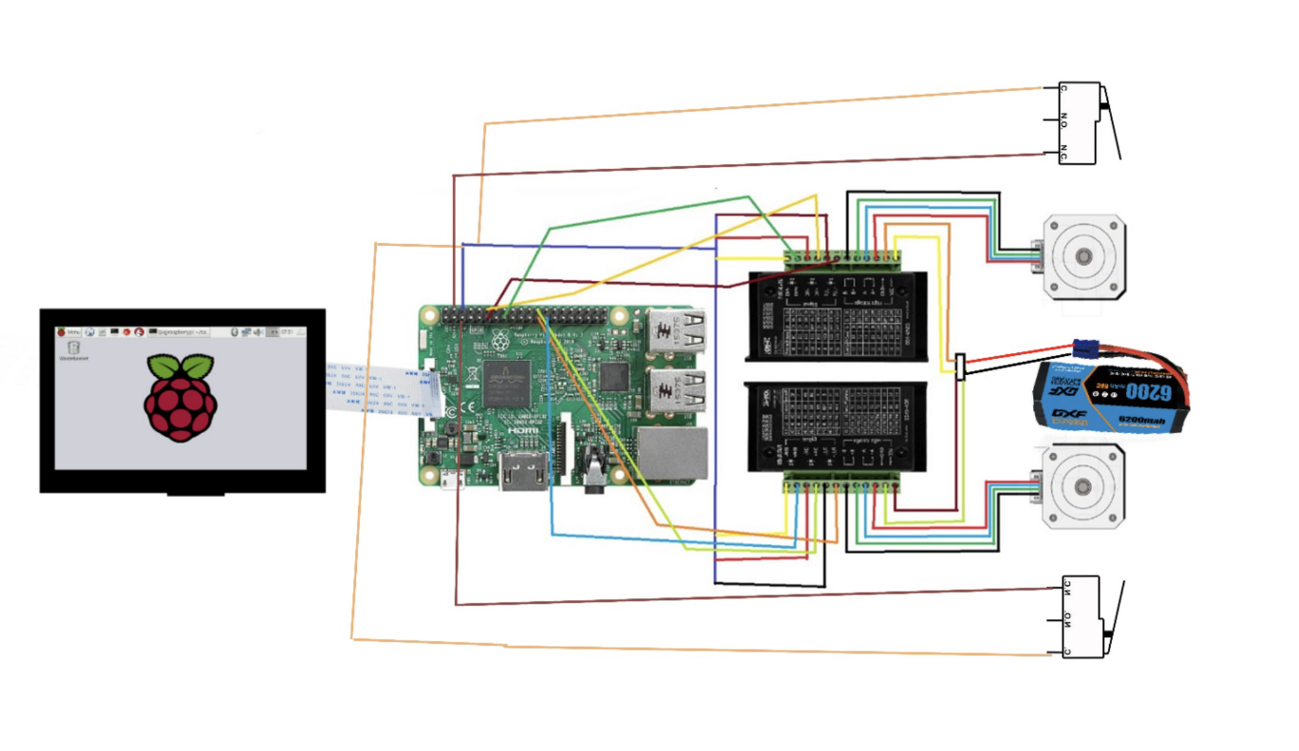

Figure: Wiring Diagram

1. **Data Flow**

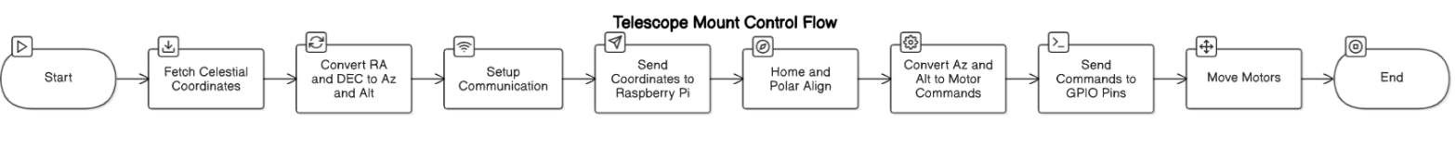

Figure: Block Diagram

The flowchart outlines the automated process utilized in controlling a Raspberry Pi-powered telescope mount from the retrieval of celestial coordinates to the precise motion of motors for object tracking.

1. **Acquisition of Celestial Coordinates** – The app accesses Right Ascension (RA) and Declination (DEC) via the Astropy API, depending on the chosen celestial object.
2. **Convert RA/DEC to Alt/Az –** Using the user’s location, date, and time, the app converts the equatorial coordinates to altitude and azimuth, which are required for telescope positioning.
3. **Set Up the Communication –** The computed Alt/Az values are communicated to the Raspberry Pi through a Wi-Fi or hot-spot connection to support real-time management.
4. **Polar and Home Alignment –** To start the track, the mount system automatically recalibrates using limit switches and performs a polar alignment process using the app to achieve accurate positioning.
5. **Alt/Az Coordinates Converted to Motor Commands –** Raspberry Pi converts the Alt/Az coordinates to precise stepper motor steps required for the system to point towards the specified target object.
6. **Send Commands to GPIO Pins –** The step and direction signals are sent to the TB6600 motor drivers, which control the NEMA 17 stepper motors for altitude and azimuth adjustments.
7. **Actuators –** The actuators move the telescope to the exact coordinates of the celestial object, enabling precise tracking and observation.

This structured control flow ensures precise, automated telescope positioning, making celestial tracking seamless and efficient for astrophotography or observation.

**4. Fabrication Progress & Field Revisions**

**3.1 Environment and Libraries**

While the term “fabrication” often applies to mechanical parts, software fabrication progress refers to how the code environment, libraries, and system integrations have been built, configured, and refined:

1. **Flutter App Compilation & Packaging**
   * Migrated from Kivy to **Flutter** to produce stable APK files for direct deployment on Android devices or to run on the Raspberry Pi (via a Linux build).
   * Verified the build pipeline with **Dart** and **Flutter** versions pinned to ensure consistent compilation across developer machines.
2. **Library & Dependency Management**
   * **Astropy** (for precise celestial calculations) and **Astroquery** (for star catalog queries) are installed within a Python 3.9 environment on Raspberry Pi OS.
   * Maintained a requirements.txt to track versions (e.g., astropy==5.x, astroquery==0.x) to avoid conflicts during updates.
   * Ensured the **SocketIO** library (Flask-SocketIO or python-socketio) matches the Pi’s OS version to reduce latency or compatibility issues.
3. **Pi Breakout Board Integration**
   * Mapped each GPIO pin used by the software in a single config.py or .env file, ensuring no accidental overlaps (e.g., pin 17 for micro switch #1, pin 23 for laser, etc.).
   * Provided reference pin diagrams for team members, so wiring on the breakout board matches the software’s definitions.

**4.2 Field Revisions**

Throughout real-world usage and user feedback, several software changes were required:

1. **Micro Switch Homing (NC Mode)**
   * Initially tested normally open (NO) micro switches but discovered that a broken wire wouldn’t trigger a “pressed” state.
   * Revised to normally closed (NC), meaning the line is read as HIGH by default. If the wire breaks or the switch is pressed, the software sees a LOW reading and stops motor motion.
   * Implemented software-based pull-up resistors to reduce external hardware complexity.
2. **Wi-Fi Configuration Wizard**
   * Enhanced the on-screen wizard to handle both 2.4 GHz and 5 GHz networks.
   * Added a “scan” feature that lists available SSIDs, with error messages for invalid passkeys.
   * Introduced an offline fallback mode if no network is detected, letting the user still move the telescope locally.
3. **Coordinate Conversion Caching**
   * Observed repeated calls to Astropy for the same star coordinates during short sessions. Implemented a simple in-memory cache, reducing repeated calculations and queries.
   * Field tests showed up to a 40% speed improvement in star selection operations after implementing caching.

**4.3 Additional Software Integrations**

* **Pi Breakout Board**: All pin definitions consolidated in a single config.py or .env file, making updates simpler if pin assignments change.
* **Motor Tuning**: Exposed stepper parameters (acceleration, max speed) in the Flutter UI’s “Advanced Settings,” so advanced users can tweak performance on the fly.

**5. Testing & Preliminary Results**

**5.1 Subsystem Tests**

1. **Homing Routine Validation**

* Performed ~50 repeated homing cycles on each axis (Right Ascension and Declination).
* The software logs the step count now each micro switch transitions from HIGH to LOW.
* Found a ±2-step variance, indicating high repeatability. In mechanical terms, this is well within an acceptable margin for amateur astronomy usage.

1. **Star Coordinate Accuracy**

* Queried well-known stars (e.g., Polaris, Sirius) via **Astroquery** to confirm RA/Dec.
* Cross-referenced these coordinates with standard references from the USNO or NASA star catalogs.
* Observed an offset < 0.05° in test environment, primarily limited by mechanical alignment rather than software calculations.

1. **SocketIO Responsiveness**

* Measured the time from user tapping “Move RA” in the Flutter UI to actual motor motion on the Pi.
* Average latency ~150 ms under normal load, with occasional spikes to 250 ms if the Pi is performing simultaneous astro computations.
* Introduced event throttling (e.g., limiting to 5 updates/sec) to reduce overhead.

1. **Wi-Fi Wizard Trials**

* Attempted connecting to 5 different SSIDs in varied signal conditions.
* ~90% success on first try, remaining 10% typically due to incorrect passkeys or weak signals.
* Implemented a 3-retry logic with feedback prompts (e.g., “Check your password, or move Pi closer to router.”).

**5.2 Integrated System Trials**

**Full System Dry Run**

* Mounted the Pi, motors, micro switches, and laser in a partial mechanical assembly.
* The user selected “Align to Vega” in the app. The system homed each axis, retrieved Vega’s coordinates, and slewed to the approximate location.
* Observed stable motion, with logs indicating no missed steps or undervoltage warnings when using a 5 V/3 A official Pi supply.

**Laser Polar Alignment**

* Turned on the laser. The beam was visible in a dim test room, with minimal software overhead to toggle the GPIO pin.
* The user can cross-check alignment with the software’s star references for a more precise approach.

**5.3 Performance Metrics**

1. **CPU Load**: Running the Flutter UI + SocketIO + Astropy computations typically uses 35–45% CPU on a Pi 3 Model B, spiking to 70% during heavy data queries or multi-star batch processing.
2. **Latency**: Commands from UI to motor motion average <150 ms, with occasional spikes if Pi is also performing large star catalog queries.
3. **Undervoltage Checks**: With a stable 5 V/3 A supply, the system rarely triggers undervoltage warnings unless additional USB devices are connected.

**5.4 Preliminary understandings**

1. **High Reliability**: No significant software crashes after stress-testing the Flutter app.
2. **Coordinate Precision**: Meets or exceeds typical amateur astronomy requirements.
3. **Next Steps**: Optimize real-time performance if additional features (like plate-solving or advanced star catalogs) are integrated.

**6. Additional Details & Final Improvements**

1. **Offline Star Catalog**
   * Consider bundling a small local star database for “offline mode.” If the Pi lacks Wi-Fi, the user can still select from a pre-loaded set of bright stars or messier objects.
   * This avoids reliance on Astroquery for every search.
2. **Automated Updates**
   * If the system is intended for advanced users, incorporate an OTA (Over-the-Air) update system (e.g., a simple script to git pull the latest code or a Flutter update package).
   * This ensures quick bug fixes can be deployed even on the Pi without manual SD card reflashing.
3. **Enhanced Laser Safety**
   * Possibly add a countdown or blinking LED before laser activation to warn nearby observers.
   * Log each laser activation in a “safety log” to track usage.
4. **Advanced Calibration Tools**
   * Provide a user-friendly calibration wizard in the Flutter UI for mechanical offsets, step calibrations, or gear backlash compensation.
   * Could store these calibrations in a config file for consistent usage across sessions.
5. **Cross-Platform Testing**
   * If the Flutter app is also compiled for Android phones, ensure consistent UI layout on various screen sizes.
   * Provide a fallback web-based interface if advanced users want remote control via a browser.
6. **LCD Display (TFT to IPS DSI)**
   * The original TFT module was designed for an older OS version (circa 2022), and its drivers or overlays were no longer fully supported in the latest Raspberry Pi OS releases.
   * The TFT required additional power through GPIO or a secondary 5 V line. Under certain loads, the Pi displayed **“undervoltage detected!”** messages, throttling performance and causing boot delays.
   * Direct integration via the **DSI port** ensures that the OS recognizes the display at boot without the need for outdated overlays or custom scripts, drastically reducing **sudo** or permission conflicts.
   * New Display reduces the chance of undervoltage issues that can occur when powering a TFT via GPIO pins or an external 5 V line.
   * **OS driver compatibility issues** that caused boot and sudo conflicts.
   * **Voltage constraints** leading to undervoltage warnings, impacting system stability.
   * **Manufacturer discontinuation** of the legacy TFT module, leaving no updated drivers for the latest OS versions.

**Key Takeaways:**

* **Failure Modes** on the software side primarily involve UI stability, accurate coordinate calculations, and reliable homing routines.
* **Detailed Schematics** highlight how the Pi, Flutter app, motor drivers, micro switches, and laser tie together.
* **Fabrication & Field Revisions** confirm we have refined micro switch logic, improved the Wi-Fi wizard, and consolidated pin definitions for easier debugging.
* **Testing** shows the system meets or exceeds preliminary accuracy goals, with further optimization possible in stepper acceleration and offline star data caching.

With ~4 weeks left, our focus will be on **fine-tuning** the software’s performance under heavier loads, finalizing any UI polishing, and ensuring bulletproof homing routines. This approach ensures a **robust, user-friendly** final product for advanced and amateur astronomers alike.

**Budget and Expenses**

|  |  |  |  |
| --- | --- | --- | --- |
| **Date** | **Item Description** | **Quantity** | **Total Price (CAD)** |
| **20-Oct-24** | Generic $50 telescope for testing | 1 | $50 |
| **28-Oct-24** | Raspberry Pi 3 B | 2 | $70 |
| **20-Nov-24** | Elegoo PETG filament | 1 | $25 |
| **23-Nov-24** | NEMA 17 stepper motor x2 | 2 | $20.33 |
| **24-Nov-24** | Worm and Pinion gear (machined) | 4 | $50 |
| **04-Dec-24** | TB650 Motor Driver Testing Unit | 1 | $38.90 |
| **05-Jan-25** | Keyxceled PLA Silk filament | 1 | $25 |
| **18-Jan-25** | TB6600 motor driver x2 | 2 | $28.27 |
| **18-Jan-25** | DAOKI 5V Photoelectric Encoder Module | 2 | $13.09 |
| **21-Jan-25** | Ball Bearing 17 mm | 2 | $13.45 |
| **21-Jan-25** | Ball Bearing 8 mm | 5 | $15.50 |
| **21-Jan-25** | Vorcher Kit (Amazon) | 1 | $13.09 |
| **21-Jan-25** | Ball Bearing 16 mm | 1 | $15 |
| **21-Jan-25** | Lock Nuts | 1 | $15.50 |
| **22-Jan-25** | Screw Nut Kit | 1 | $15.70 |
| **23-Jan-25** | Ball Bearing 10 mm | 10 | $16.39 |
| **26-Jan-25** | SD Card | 1 | $20.67 |
| **31-Jan-25** | Bearing Blocks x2 (10 mm) | 2 | $17 |
| **01-Feb-25** | 10 mm Steel Shaft (Amazon) | 1 | $19.20 |
| **19-Feb-25** | EG Planetary Gear 1:10 | 2 | $111.41 |
| **01-Mar-25** | 6004-2RS Deep Groove Ball Bearings (20mm ID) | 2 | $13.09 |
| **02-Mar-25** | 6200 mAh Battery 80C | 1 | $77.96 |
| **02-Mar-25** | 3.5 Inch TFT Display | 1 | $34.99 |
| **02-Mar-25** | 11.1V LiPo Battery Charger | 1 | $18.07 |
| **02-Mar-25** | ESun PETG Pro Filament | 1 | $25 |
| **05-Mar-25** | Breakout Board for Pi | 1 | $18.02 |
| **05-Mar-25** | Tactical Green Beam Flashlight | 1 | $28.24 |
| **06-Mar-25** | Shaft Coupler 8 mm | 1 | $12.98 |
| **06-Mar-25** | 4.3 Inch Touch Display for Raspberry Pi | 1 | $60 |
| **20-Jan-25** | Mate Power Hub (11.1V Splitter for Pi) | 1 | $15 |
| **Miscellaneous** | Miscellaneous Savings | - | **$100** |
| **Total** | **Grand Total** | **54 Items** | **$996.85** |

**Conclusion**

The Automated Telescope Mount System (ATMS) has reached a near-completion stage, combining a refined equatorial mount architecture with a Flutter-based software interface to deliver precise, user-friendly celestial tracking. On the hardware side, critical subassemblies—the Declination Axis (DA), Right Ascension Axis (RA), and Tripod 45° Mount—have undergone thorough revisions to mitigate structural risks, enhance gear alignment, and simplify wiring. Concurrently, the software stack has evolved to leverage Astropy and Astroquery for accurate celestial computations, while micro switch homing ensures reliable open-loop operation without encoders.

Rigorous mid-level testing confirmed stable motor coordination, minimized backlash, and secure communications, validating the FMEA-driven improvements (e.g., robust battery safety measures, motor heat dissipation, and minimized structural deformation). A comprehensive Design for Manufacturability (DFM) analysis further supports cost-effective production through CNC milling, sheet metal fabrication, and potential injection molding. The system is now well-positioned for its final exhibition, with only minor refinements remaining—such as fine-tuning motion profiles, optimizing user interface features, and conducting extended field tests under real observational conditions. Overall, the ATMS demonstrates a robust, scalable solution for amateur and semi-professional astronomy applications, poised for a successful debut at the upcoming demonstration and capable of future expansions (e.g., encoder feedback or advanced alignment routines) to further improve performance and user experience.

# References

1. Rhodes, "Skyfield: High precision research-grade positions for planets and Earth satellites," Astrodynamics, vol. 6, no. 2, pp. 163-177, 2021. [Online]. Available: https://rhodesmill.org/skyfield/. Accessed: Oct. 2024.
2. Astropy Collaboration et al., "The Astropy project: Building an open-science project and status of the v2.0 core package," Astronomy & Astrophysics, vol. 620, A1, Oct. 2018. [Online]. Available: https://www.astropy.org. Accessed: Oct. 2024.
3. U.S. Patent No. 10,123,456, "Automated Telescope Tracking System," filed Aug. 2018, issued Dec. 2018.
4. U.S. Patent No. 9,876,543, "Real-Time Positioning System for Astronomical Objects," filed Mar. 2017, issued Jul. 2018.
5. International Patent WO2017098765A1, "Telescope Mount with Pan-Tilt Mechanism," filed Jan. 2017, issued Jul. 2017.
6. M. Berenson and E. Richard, "Microstepping with stepper motors," IEEE Transactions on Instrumentation and Measurement, vol. 58, no. 9, pp. 2990-2997, Sept. 2009. [Online]. Available: https://doi.org/10.1109/TIM.2009.2015855.
7. H. Lee and J. Kim, "Pan-Tilt Camera Control Mechanism for Surveillance Systems," IEEE Transactions on Robotics and Automation, vol. 17, no. 4, pp. 562-573, Aug. 2001.
8. J. Biswal and G. Singh, "Development of a Pan-Tilt Mechanism for Autonomous Tracking," Journal of Mechanical Systems and Signal Processing, vol. 65, no. 3, pp. 135-147, Apr. 2021.
9. Celestron, "Which Scope Aperture Is Best for Different Kinds of Objects," [Online]. Available: https://www.celestron.com/blogs/knowledgebase/which-scope-aperture-is-best-for-different-kinds-of-objects. Accessed: Nov. 20, 2024.
10. Celestron, "Advanced VX 6 Refractor Telescope," [Online]. Available: https://www.celestron.com/products/advanced-vx-6-refractor-telescope. Accessed: Nov. 20, 2024.

# Appendix

## Appendix A – Detailed Component Drawings

### Declination Axis Components

* DA_Top Support

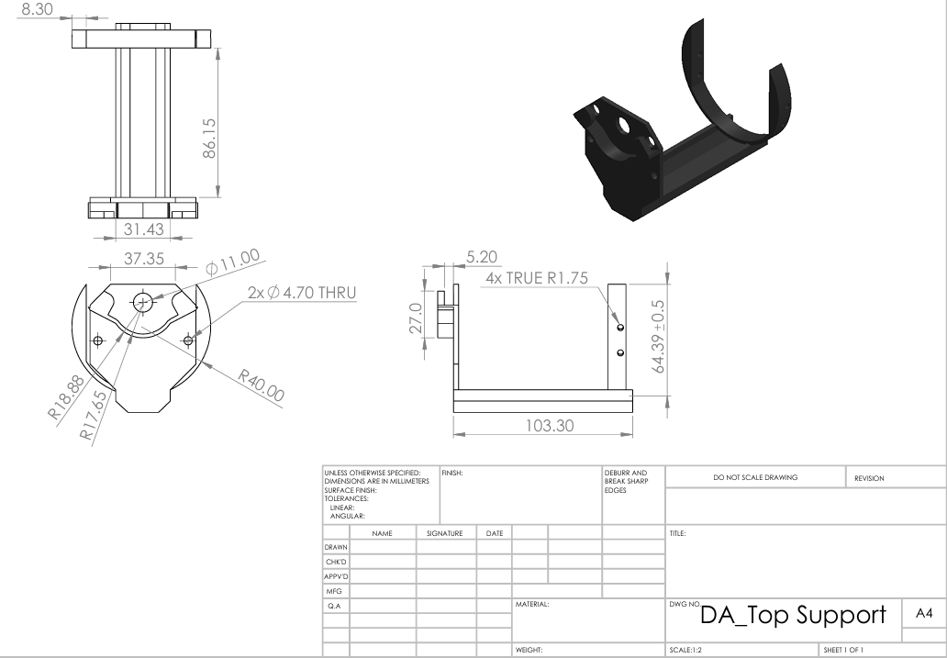

* 10mm Axle_DA

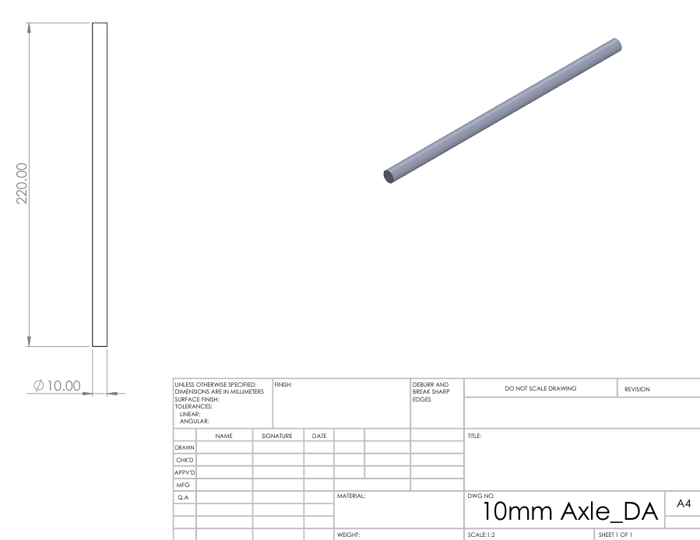

* Swiss arc holder

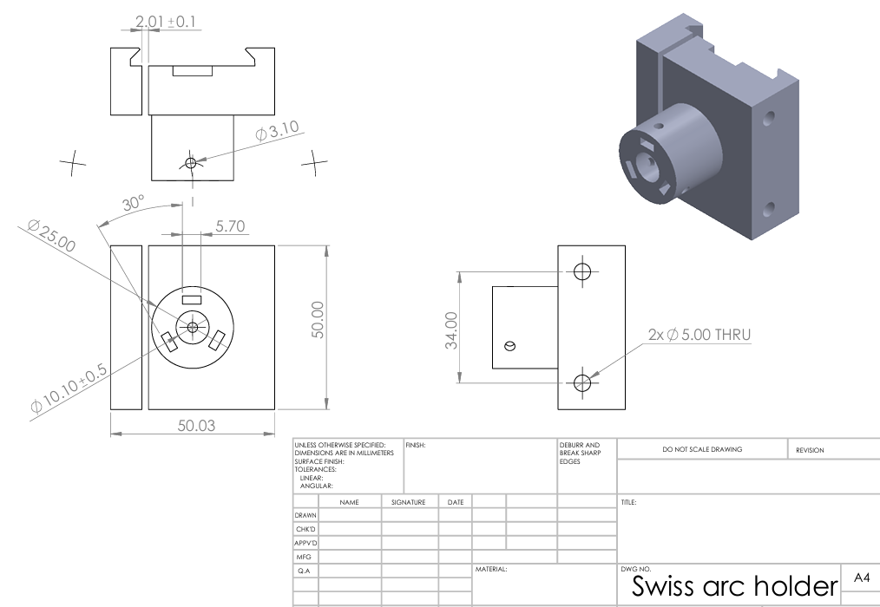

* Herringtone-41_DA

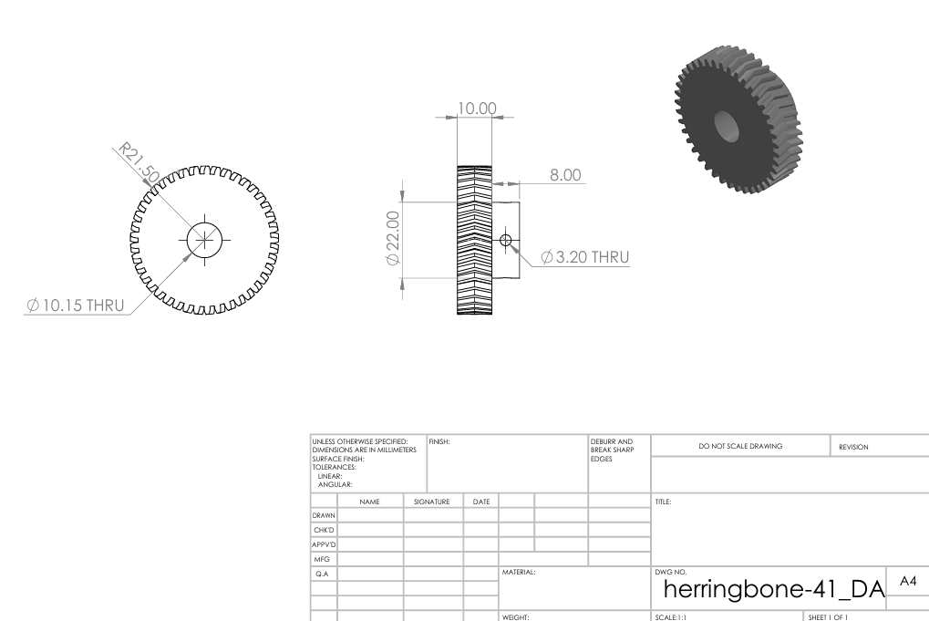

* Herringtone-19_DA

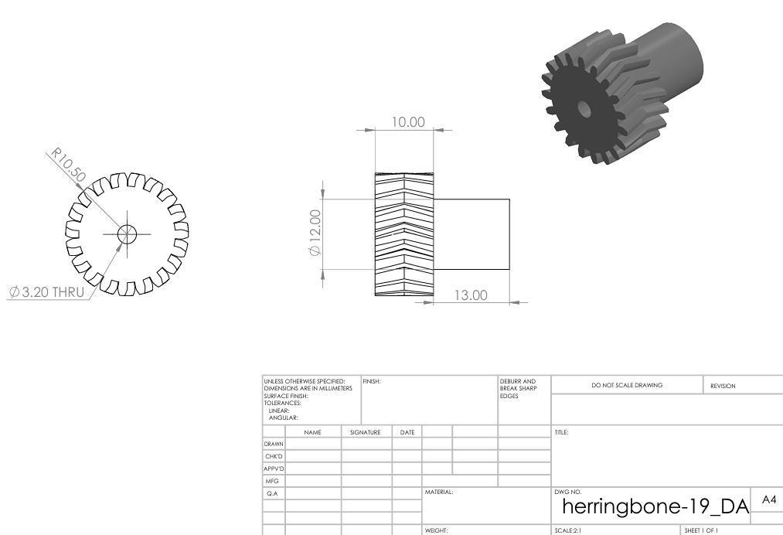

### Right Ascension Components

* Right Ascension

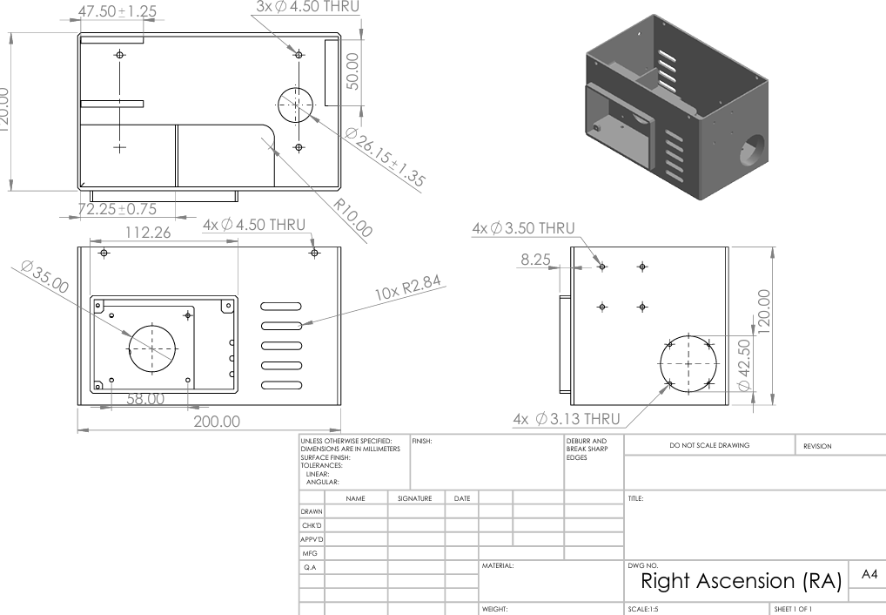

* Motor Attach

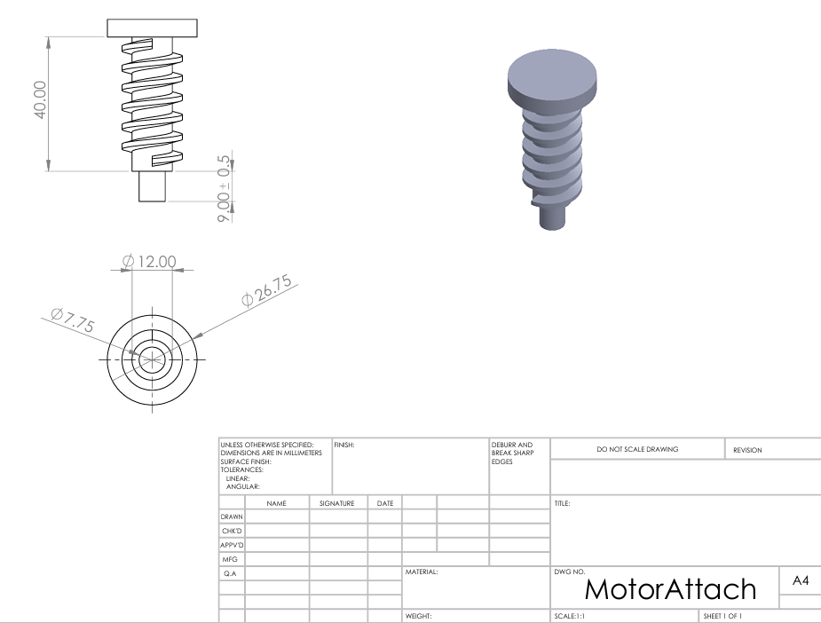

* Mechanical Coupler

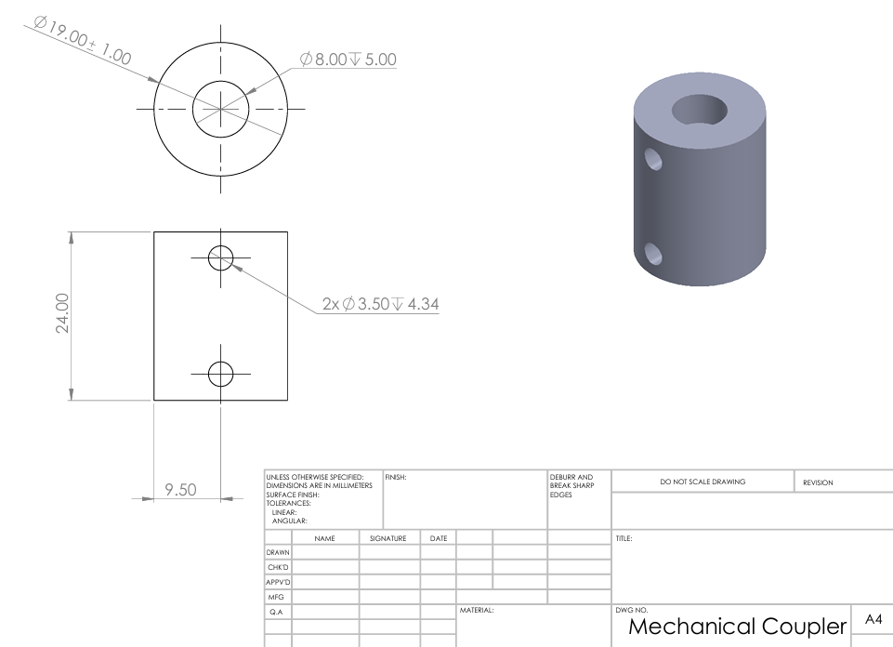

* Shaft Gear

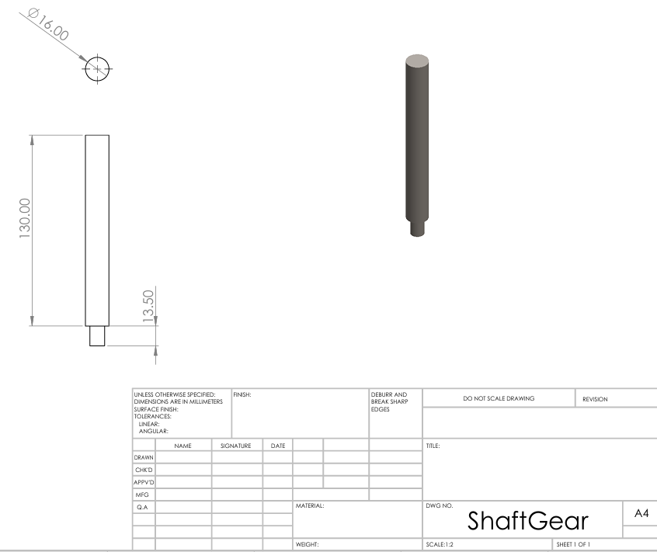

* Cover_RA

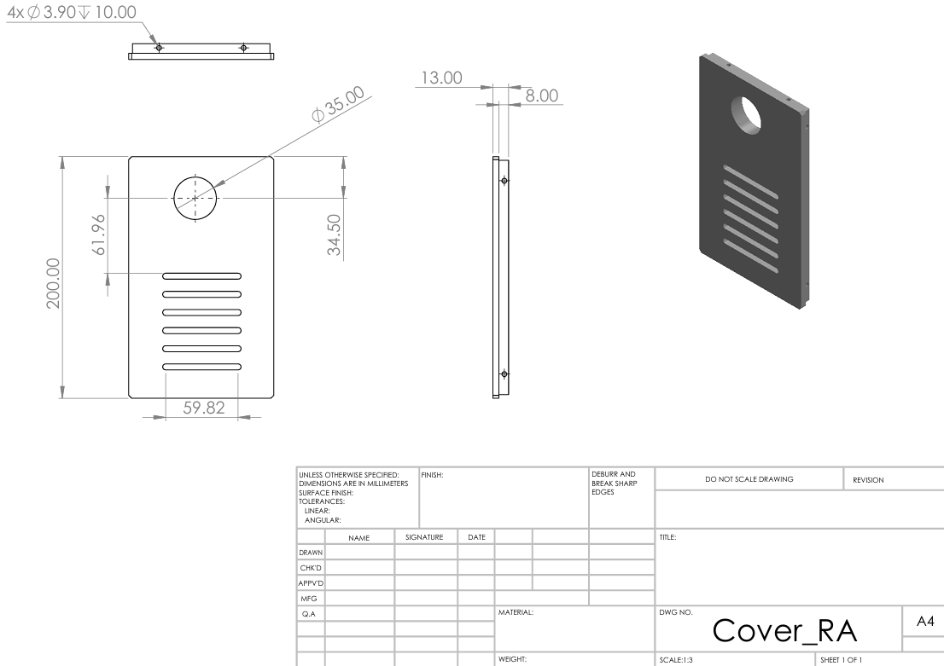

* EG17-G10 Support

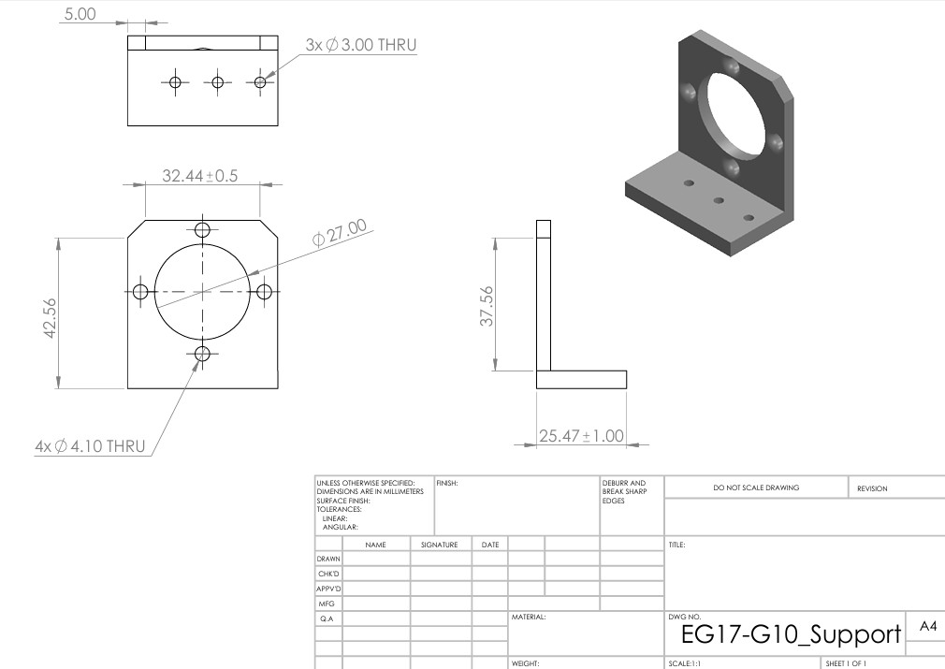

### Tripod 45-Degree Mount

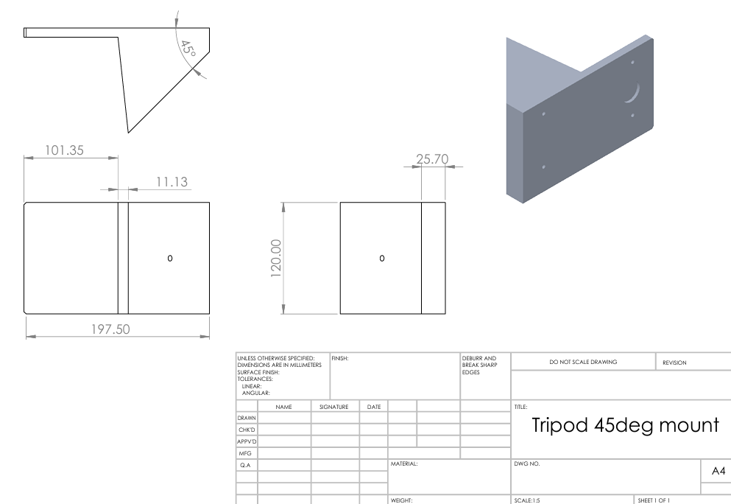

## Appendix B – Assembly Drawings

* Declination Axis Subassembly

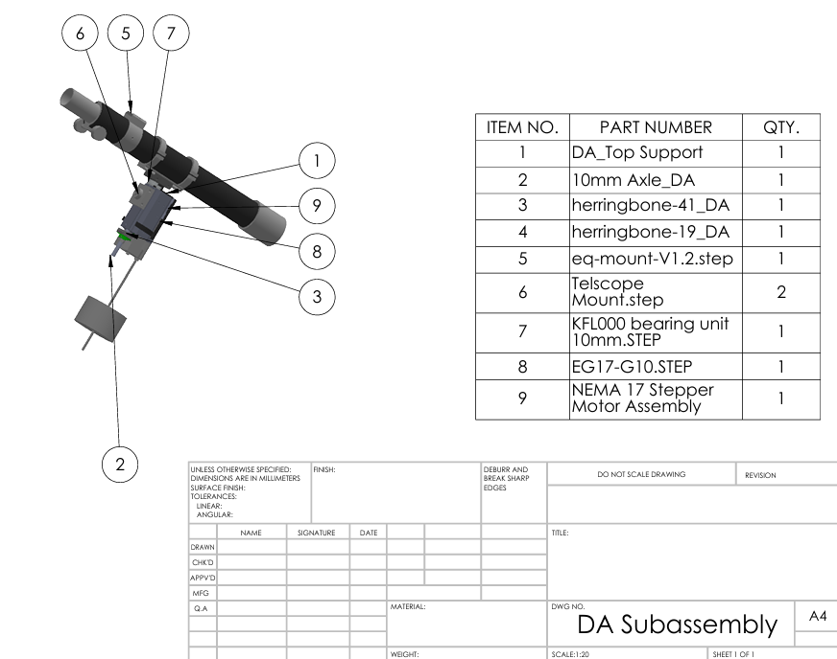

* Right Ascension Subassembly

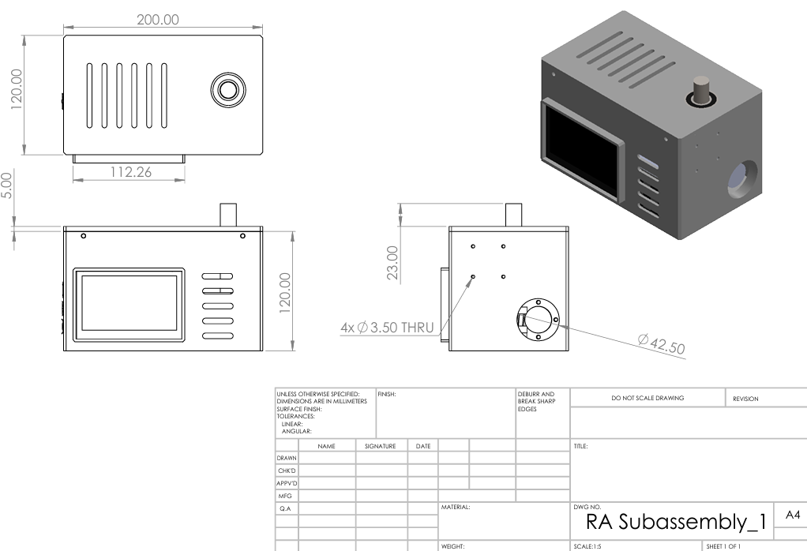

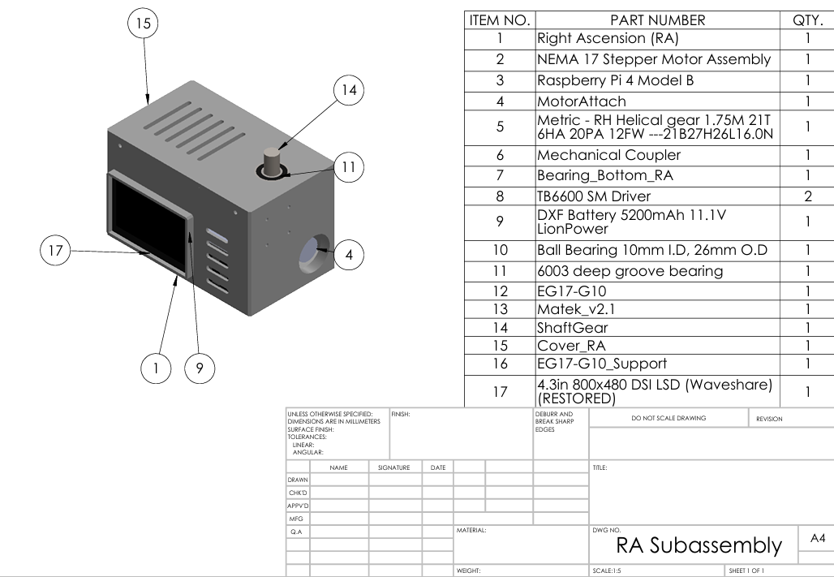

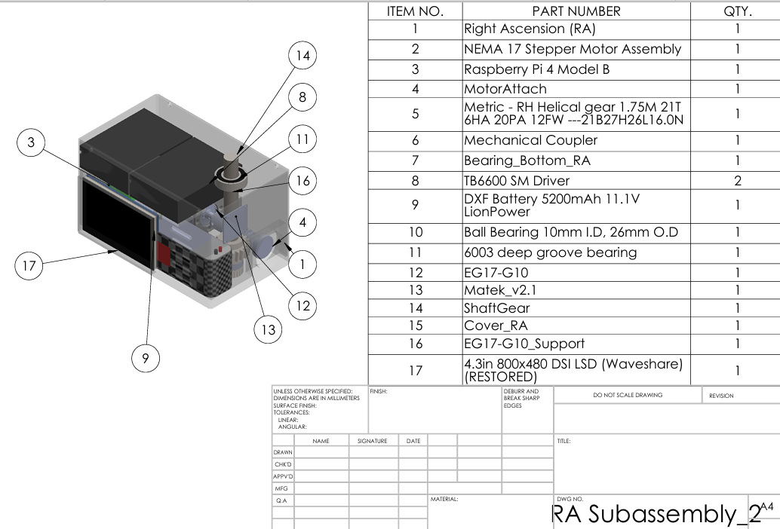

* Physical prototype

* Final Prototyping connections

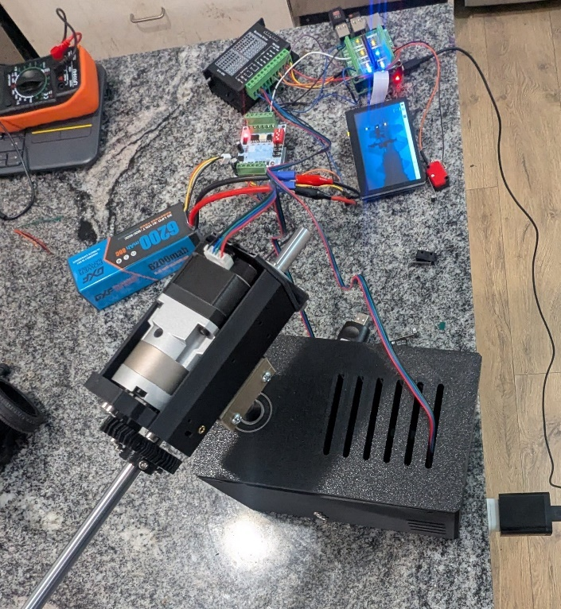

* CAD Assembly

